# Incorrect Calculation Of Fines

Test Script: IncorrectCalculationOfFinesTest.java

**Expected:**

The test should have run smoothly with no assert failed error as the patron should have been issued a loan amount of $1

**Results:**

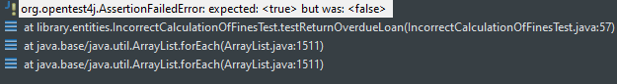The test failed with an assert failed error as when the patron tried to return their late book the system did not issue them a fine, therefore causing the test to fail.

**After Fix:**

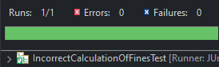

The patron is fined the correct amount for their overdue book

# Incorrect **Fine Amount Levied**

Test Script: IncorrectFineAmountLeviedTest.java

**Expected:**

The expected result was that patron should have been fined $2 as the book loan is 2 days overdue

The test should have run smoothly with no assert failed error as the patron should have been issued a loan amount of $1

**Results:**

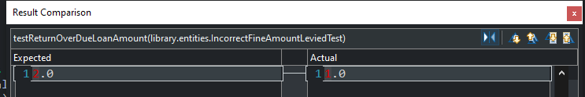

The test failed with an assert error as when the patron tried to return their 2 day overdue book the system issued half of the fine it should have.

**After Fix:**

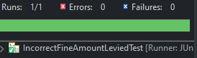

The test runs smoothly and the patron is fined the correct amount for their overdue book.